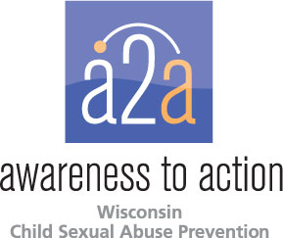

Child sexual abuse prevention education contracts for service awarded to Wisconsin agencies

The Exchange Family Resource Center, Janesville and the Sexual Assault Crisis Center, Appleton have been awarded contracts for service to support child sexual abuse education in youth-serving agencies in their communities. The awards are part of a joint funding project by Children’s Hospital’s Child Abuse Prevention Fund and the Wisconsin Children’s Trust Fund.
Using the Awareness to Action Child Sexual Abuse Prevention Policy and Procedure Development training, the contracted agencies will provide hands on technical assistance to the youth-serving agencies. In addition, youth-serving agencies that participate in the training also will receive Stewards of Children training.
Awareness to Action, a program of Children’s Hospital of Wisconsin, is an initiative focused on preventing child sexual abuse by helping adults and communities take action to protect children through awareness, education, prevention, advocacy and action.

