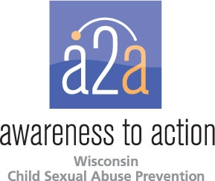

Mobilizing to Prevent Child Sexual Abuse

Awareness to Action supports the Stewards of Children™ training, a child sexual abuse prevention program developed by Darkness to Light, that increases knowledge, improves attitudes and changes child-protective behaviors. Trained facilitators deliver the program throughout the state and ask participants to complete a pre and post survey to measure knowledge and behavior. Some highlights from the 2014 data include:

- 34% increase in participants stating that adults should talk to children under the age of 7 about sexual abuse.
- 27% increase in the number of participants knowing that very few reported incidents of child sexual abuse are false.
- 34% increase in the number of participants who believe fewer children would be sexually abused if adults made more conscious choices about situations in which children are placed
- 98% of participants left the training with the belief they know what to do if a child reports sexual abuse to them.

For more information about Stewards of Children™, email a2a@chw.org.

