­­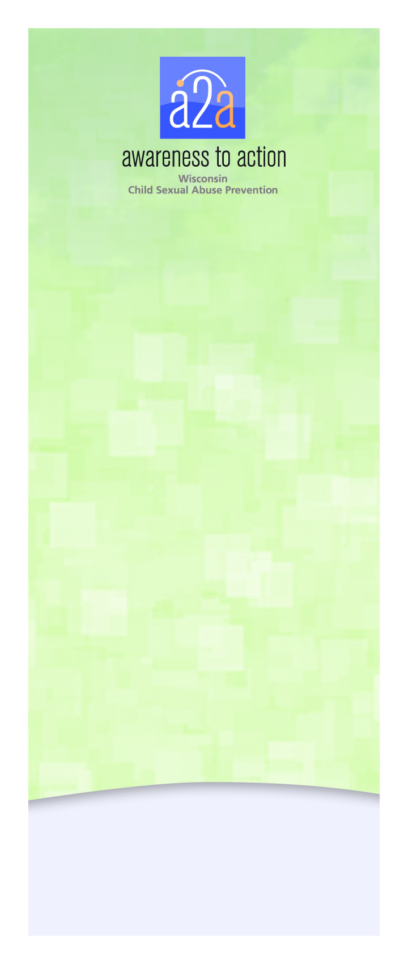





**Be Aware**

Children have many opportunities to participate in high quality programs in our community. It is our responsibility as caring adults to ask the following questions to ensure their safety while participating:

**Does the program/organization work to select the best possible people for staff and volunteer positions?** This includes conducting background checks, screening applicants and checking references.

**Does the program/organization work to ensure the safety of interactions between youth and employees, volunteers and each other?** Does the agency define what is considered appropriate interaction, limit on one-on-one interactions, and provide adequate supervision?



**Be Aware**

Children have many opportunities to participate in high quality programs in our community. It is our responsibility as caring adults to ask the following questions to ensure their safety while participating:

**Does the program/organization work to select the best possible people for staff and volunteer positions?** This includes conducting background checks, screening applicants and checking references.

**Does the program/organization work to ensure the safety of interactions between youth and employees, volunteers and each other?** Does the agency define what is considered appropriate interaction, limit on one-on-one interactions, and provide adequate supervision?



**Be Aware**

Children have many opportunities to participate in high quality programs in our community. It is our responsibility as caring adults to ask the following questions to ensure their safety while participating:

**Does the program/organization work to select the best possible people for staff and volunteer positions?** This includes conducting background checks, screening applicants and checking references.

**Does the program/organization work to ensure the safety of interactions between youth and employees, volunteers and each other?** Does the agency define what is considered appropriate interaction, limit on one-on-one interactions, and provide adequate supervision?

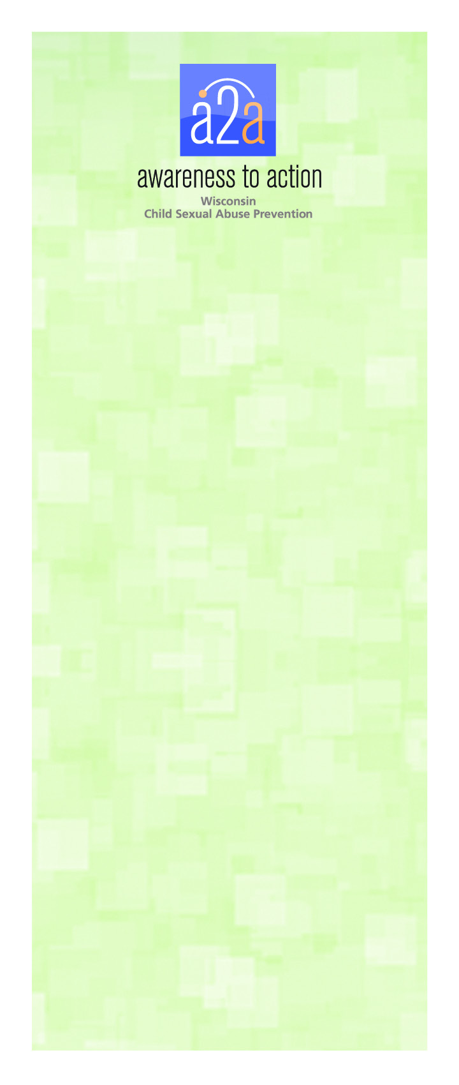

**Does the program/organization have policies on how to prevent, recognize and respond to inappropriate and harmful behaviors?** All agencies should have procedures in place to monitor interactions between youth and staff/volunteers/other youth. It should also have a well-defined reporting structure so that staff/volunteers and participants know who to contact with concerns.

**Does the program/organization do all it can to ensure a safe environment**? This includes making sure the physical environment is open and visible to multiple people.

**How does the program/organization respond to inappropriate behavior and breaches in policy?** Every employee and volunteer at the agency should be aware of how to respond and what should be reported – both within the agency and what needs to be reported directly to Child Protective Services.

**Does the agency provide training to staff and volunteers regarding child sexual abuse prevention?** Awareness to Action can provide support to youth serving organizations on developing policies and procedures and provide trainings to help ensure safe environments. For more information, visit [www.A2Awisconsin.org](http://www.A2Awisconsin.org).

Adopted from The Centers for Disease Control and Prevention document “Preventing Child Sexual Abuse within Youth-Serving Organizations: Getting Started on Policies and Procedures (<http://www.cdc.gov/ViolencePrevention/pdf/PreventingChildSexualAbuse-a.pdf>).”

**Does the program/organization have policies on how to prevent, recognize and respond to inappropriate and harmful behaviors?** All agencies should have procedures in place to monitor interactions between youth and staff/volunteers/other youth. It should also have a well-defined reporting structure so that staff/volunteers and participants know who to contact with concerns.

**Does the program/organization do all it can to ensure a safe environment**? This includes making sure the physical environment is open and visible to multiple people.

**How does the program/organization respond to inappropriate behavior and breaches in policy?** Every employee and volunteer at the agency should be aware of how to respond and what should be reported – both within the agency and what needs to be reported directly to Child Protective Services.

**Does the agency provide training to staff and volunteers regarding child sexual abuse prevention?** Awareness to Action can provide support to youth serving organizations on developing policies and procedures and provide trainings to help ensure safe environments. For more information, visit [www.A2Awisconsin.org](http://www.A2Awisconsin.org).

Adopted from The Centers for Disease Control and Prevention document “Preventing Child Sexual Abuse within Youth-Serving Organizations: Getting Started on Policies and Procedures (<http://www.cdc.gov/ViolencePrevention/pdf/PreventingChildSexualAbuse-a.pdf>).”

**Does the program/organization have policies on how to prevent, recognize and respond to inappropriate and harmful behaviors?** All agencies should have procedures in place to monitor interactions between youth and staff/volunteers/other youth. It should also have a well-defined reporting structure so that staff/volunteers and participants know who to contact with concerns.

**Does the program/organization do all it can to ensure a safe environment**? This includes making sure the physical environment is open and visible to multiple people.

**How does the program/organization respond to inappropriate behavior and breaches in policy?** Every employee and volunteer at the agency should be aware of how to respond and what should be reported – both within the agency and what needs to be reported directly to Child Protective Services.

**Does the agency provide training to staff and volunteers regarding child sexual abuse prevention?** Awareness to Action can provide support to youth serving organizations on developing policies and procedures and provide trainings to help ensure safe environments. For more information, visit [www.A2Awisconsin.org](http://www.A2Awisconsin.org).

Adopted from The Centers for Disease Control and Prevention document “Preventing Child Sexual Abuse within Youth-Serving Organizations: Getting Started on Policies and Procedures (<http://www.cdc.gov/ViolencePrevention/pdf/PreventingChildSexualAbuse-a.pdf>).”