­­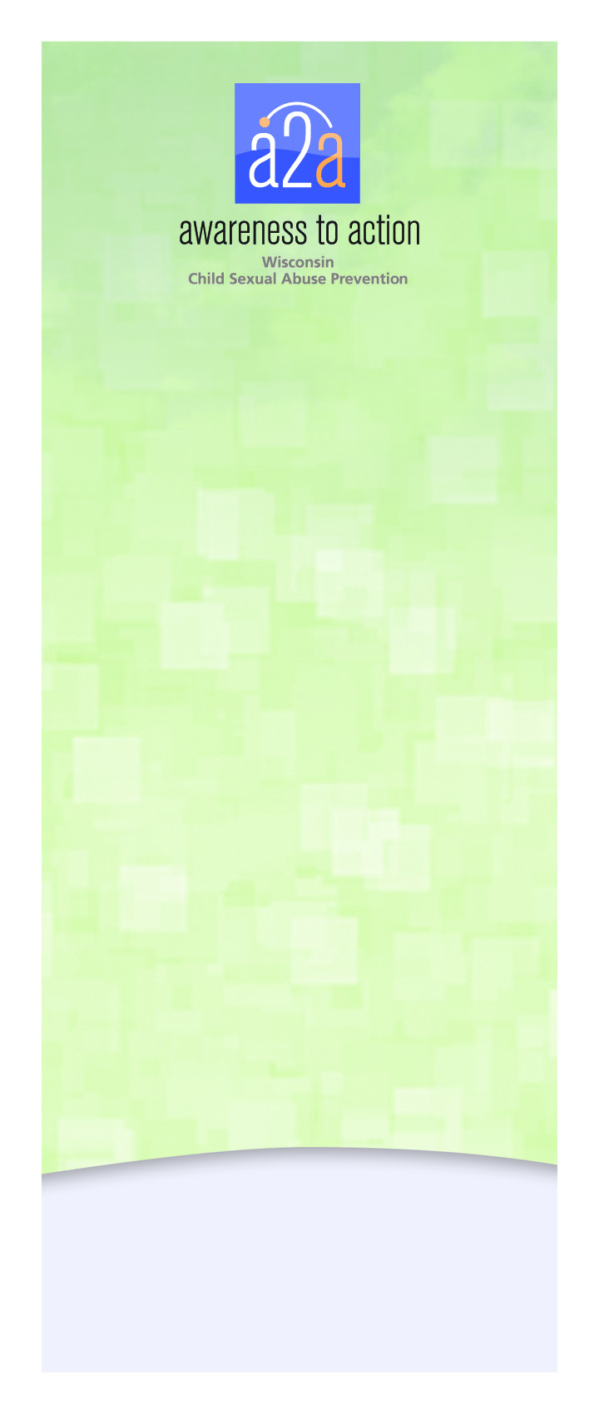

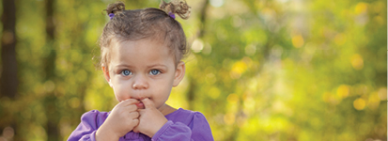

**Be Aware.** We may not like to think about it – or even believe it – but children experience sexual abuse at alarming rates. We can do better to protect children – it only takes a minute to become aware. Child sexual abuse is preventable. Take time to learn how you can help protect children.

**Understanding child sexual abuse – what is it?**

Sexual abuse is when an adult or older or more powerful child involves another child in sexual activity or awareness. It may not involve touch.

**As a parent or concerned adult – how can I help?**

There are things you can do to make your child less vulnerable to sexual abuse and increase the chance they will come to you if they are abused.

**Teach children about their private parts so they have the language to talk with you about possible abuse.** Let them know no one should look at or touch their private parts for no good reason (or be asked to look or touch someone else’s private parts). A good reason might be a doctor visit. Teach children that if someone touches or wants to look at their private parts they should say “NO” and tell a trusted adult.



**Be Aware.** We may not like to think about it – or even believe it – but children experience sexual abuse at alarming rates. We can do better to protect children – it only takes a minute to become aware. Child sexual abuse is preventable. Take time to learn how you can help protect children.

**Understanding child sexual abuse – what is it?**

Sexual abuse is when an adult or older or more powerful child involves another child in sexual activity or awareness. It may not involve touch.

**As a parent or concerned adult – how can I help?**

There are things you can do to make your child less vulnerable to sexual abuse and increase the chance they will come to you if they are abused.

**Teach children about their private parts so they have the language to talk with you about possible abuse.** Let them know no one should look at or touch their private parts for no good reason (or be asked to look or touch someone else’s private parts). A good reason might be a doctor visit. Teach children that if someone touches or wants to look at their private parts they should say “NO” and tell a trusted adult.



**Be Aware.** We may not like to think about it – or even believe it – but children experience sexual abuse at alarming rates. We can do better to protect children – it only takes a minute to become aware. Child sexual abuse is preventable. Take time to learn how you can help protect children.

**Understanding child sexual abuse – what is it?**

Sexual abuse is when an adult or older or more powerful child involves another child in sexual activity or awareness. It may not involve touch.

**As a parent or concerned adult – how can I help?**

There are things you can do to make your child less vulnerable to sexual abuse and increase the chance they will come to you if they are abused.

**Teach children about their private parts so they have the language to talk with you about possible abuse.** Let them know no one should look at or touch their private parts for no good reason (or be asked to look or touch someone else’s private parts). A good reason might be a doctor visit. Teach children that if someone touches or wants to look at their private parts they should say “NO” and tell a trusted adult.

*Awareness to Action is a program of*

*Children’s Hospital of Wisconsin Community Services with funding provided by Children’s Hospital of Wisconsin and the Child Abuse and Neglect Prevention Board*



*Awareness to Action is a program of*

*Children’s Hospital of Wisconsin Community Services with funding provided by Children’s Hospital of Wisconsin and the Child Abuse and Neglect Prevention Board*



*Awareness to Action is a program of*

*Children’s Hospital of Wisconsin Community Services with funding provided by Children’s Hospital of Wisconsin and the Child Abuse and Neglect Prevention Board*



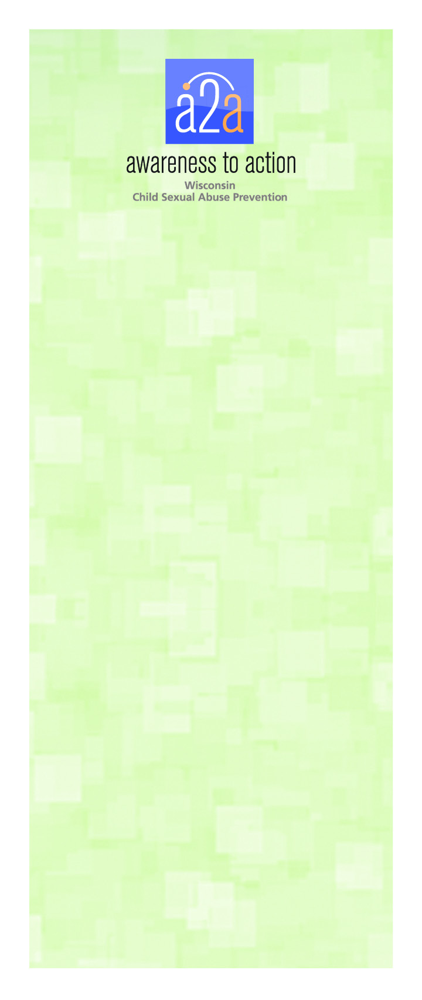

**Tell children it’s okay to say “NO” to touch that makes them scared or uncomfortable.** Tell them their “NO” will be respected by you whether it is play, tickling or hugging.

**Talk to your child about the difference between a secret and a surprise.** A surprise is something nice like a party or gift. Secrets are things someone asks you to keep hidden from your parents or that break family rules.

**Find ways to incorporate “what ifs” into everyday situations.** This lets your child practice newly learned skills. Create ways to open communication about relevant topics and listen to their thoughts.

**Show kids they can share things that may be shameful to them.** Children who are abused often believe it was their fault because the offender has told them so. How do you respond when your child tells you they lost their lunch money or got in trouble? Supporting your child, even when they’ve done wrong, creates trust and makes them more likely to come to you with bigger issues.

**Who are the offenders?** Offenders are male or female, young or old, and from any economic/ethnic group. Statistics say nearly 96% of offenders know their victims and could include family members.

**What if a child discloses to me?** If a child discloses abuse, they need someone to respond calmly and without judgment, and to be believed and protected. Tell them that telling was the right thing, and it wasn’t their fault.

**For more information, visit:**

**a2awisconsin.org.**

**Tell children it’s okay to say “NO” to touch that makes them scared or uncomfortable.** Tell them their “NO” will be respected by you whether it is play, tickling or hugging.

**Talk to your child about the difference between a secret and a surprise.** A surprise is something nice like a party or gift. Secrets are things someone asks you to keep hidden from your parents or that break family rules.

**Find ways to incorporate “what ifs” into everyday situations.** This lets your child practice newly learned skills. Create ways to open communication about relevant topics and listen to their thoughts.

**Show kids they can share things that may be shameful to them.** Children who are abused often believe it was their fault because the offender has told them so. How do you respond when your child tells you they lost their lunch money or got in trouble? Supporting your child, even when they’ve done wrong, creates trust and makes them more likely to come to you with bigger issues.

**Who are the offenders?** Offenders are male or female, young or old, and from any economic/ethnic group. Statistics say nearly 96% of offenders know their victims and could include family members.

**What if a child discloses to me?** If a child discloses abuse, they need someone to respond calmly and without judgment, and to be believed and protected. Tell them that telling was the right thing, and it wasn’t their fault.

**For more information, visit:**

**a2awisconsin.org.**

**Tell children it’s okay to say “NO” to touch that makes them scared or uncomfortable.** Tell them their “NO” will be respected by you whether it is play, tickling or hugging.

**Talk to your child about the difference between a secret and a surprise.** A surprise is something nice like a party or gift. Secrets are things someone asks you to keep hidden from your parents or that break family rules.

**Find ways to incorporate “what ifs” into everyday situations.** This lets your child practice newly learned skills. Create ways to open communication about relevant topics and listen to their thoughts.

**Show kids they can share things that may be shameful to them.** Children who are abused often believe it was their fault because the offender has told them so. How do you respond when your child tells you they lost their lunch money or got in trouble? Supporting your child, even when they’ve done wrong, creates trust and makes them more likely to come to you with bigger issues.

**Who are the offenders?** Offenders are male or female, young or old, and from any economic/ethnic group. Statistics say nearly 96% of offenders know their victims and could include family members.

**What if a child discloses to me?** If a child discloses abuse, they need someone to respond calmly and without judgment, and to be believed and protected. Tell them that telling was the right thing, and it wasn’t their fault.

**For more information, visit:**

**a2awisconsin.org.**

©2013 Children’s Hospital of Wisconsin. All rights reserved.

©2013 Children’s Hospital of Wisconsin. All rights reserved.

